Design and Development of a Mobile E-Commerce Application for Raw World Using .NET MAUI and ASP.NET Core

Module/Course: Development project Final Project
Student-Name: Md Allauddin Rakib
P-Number: P2837503
Programme: Computer Science
Institution: De Montfort University.
Supervisor: Eugene Louis Batie Badzongoly
Submission Date: 2026/05

Abstract
The small and medium enterprises working in the food and beverage sector usually employ ordering procedures that hinder them from performing efficiently as well as participating in online activities related to their customers. This paper describes the design, development, and evaluation of an e-commerce app prototype for an authentic juice company called Raw World. In designing the prototype, we used .NET MAUI for creating the Android mobile application and ASP.NET Core Web API with MySQL for creating the back-end following the model-view-controller paradigm. Some core functions include user authentication using JSON web tokens that separate the customer from the administrator using the role-based access control, product browsing and searching, shopping cart management, a payment gateway that supports debit/credit card payments, as well as bKash and Nagad mobile wallets, placing orders and order tracking, and a custom admin panel for managing products and orders. It was developed based on Agile techniques in eight weeks and was tested for usability among ten subjects using System Usability Scale (SUS), scoring 76.5, which is Good and higher than the average for the industry. All API endpoints met the established criteria of responding within two seconds.
Contents
1. Introduction 2
1.1 Background 2
1.2 Problem Statement 3
1.3 Aim and Objectives 3
1.4 Significance / Contribution 4
1.5 Structure of the Thesis 5
2. Literature Review 5
2.1 Key Concepts and Definitions 5
2.2 Related Work 7
2.3 Research Gaps 8
2.4 Summary 8
3. Methodology 9
3.1 Research Design 9
3.2 Data Collection 9
3.3 Sampling / Participants 9
3.4 Instruments / Materials 10
3.5 Data Analysis Procedures 10
3.6 Ethical Considerations 11
4. Technical Details 12
4.1 System Overview 12
4.2 Requirements 12
4.3 System Architecture 14
4.4 Implementation Details 16
4.5 Testing and Validation 19
5. Critical Analysis / Results and Discussion 19
5.1 Results 19
5.2 Discussion 21
5.3 Comparison with Related Work 22
5.4 Limitations 23
6. Recommendations 23
6.1 Practical Recommendations 23
6.2 Recommendations for Future Work 24

1. Introduction

1.1 Background
Globally, mobile internet availability has significantly altered how consumers research products, compare them, and make purchases. Mobile commerce is the term for business activities carried out using mobile phones via wireless connections. Its use has grown from a modest mode of conducting business to the primary way that businesses shop online. By 2025, mobile commerce is expected to account for over 70% of all worldwide e-commerce sales, according to Statista (2024). The growing number of smartphones worldwide, improved mobile payment systems, and consumer satisfaction with the ease of making purchases at any time and from any location all contribute to this increase.
Although they face difficulties, small and medium-sized businesses in the food and beverage sector might profit from this trend. On the one hand, mobile commerce makes it possible for companies to serve customers wherever they may be. Businesses can become less reliant on it. manual order-taking processes, and will face competition from businesses with more sophisticated digital capabilities. The time and money required to build and maintain such an infrastructure is the issue here.
Fresh juices, smoothies, and detox drinks are among the items offered by Raw World, a legitimate juice company. At the moment, the brand takes orders and conducts sales activities through physical stores and direct client interaction. Even if it functions successfully on a small scale, there are certain operational challenges, such as manual order registration, order tracing issues, and challenges engaging with consumers outside of the store or after business hours. The absence of a digital order-taking platform becomes problematic due to the continuous shifts in customer behavior.
The project was carried out to develop a mobile e-commerce platform for Raw World in order to address the previously described issue.

1.2 Problem Statement
There is not currently an online gateway that allows customers to browse Raw World's product catalog, place orders, and track the progress of their delivery. Orders are manually placed by going to the physical store or getting in touch with the business directly via phone or instant messaging. These challenges are the result of several interconnected factors.
The first issue is the possibility of human error because order management is a manual procedure. The second problem is that Raw World lacks an internet platform for contacting people from anywhere in the world at any time. The absence of an analytical system to collect data on order patterns and consumer behavior is the third issue. Lastly, the absence of an online platform prevents customers from tracking their order history or keeping an eye on their orders independently.
When taken as a whole, these problems have an impact on Raw World's productivity, client satisfaction, and scalability and provide compelling evidence for implementing digital solutions by developing a mobile application.

1.3 Aim and Objectives
Additionally, because there is no online portal, customers are unable to track their past transactions or monitor the status of their purchases. These elements have an impact on Raw World's productivity, customer satisfaction, and capacity to expand operations. They also highlight the necessity of embracing technology while creating a mobile application. The project's goal is to develop an integrated, scalable, and secure backend API to satisfy e-commerce requirements.
The following are the project's specific objectives:
• Reviewing the literature on SMEs' digital transformation, cross-platform development, usability testing, and mobile commerce
• Analyzing functional and non-functional requirements in light of Raw World's circumstances
• Creating a database schema and mobile application system design with MySQL, ASP.NET Core Web API, and.NET MAUI
• Creating a mobile application that allows users to browse and search, add items to their basket, place orders, and sign up or sign in with roles.
• Creating a simulation of the payment process that accepts Nagad mobile money, bKash, and card payments
• Developing an administration site for product management and order status management for customers
• Using role-based access control and JWT authentication to separate customer and administrative features
• Testing the app's usability with a few users using the System Usability Scale
• Comparing non-functional criteria with system security and performance• Create a thorough project report that details design choices, implementation difficulties, and assessment results.

1.4 Significance / Contribution
The current study makes several important contributions to the field of applied mobile computing. It begins by describing a real, tested implementation of a full stack mobile commerce application that was created using both ASP.NET Core and.NET MAUI, which are still underrepresented in the literature from a practical standpoint. Specifically, a number of issues pertaining to the application of the aforementioned frameworks were resolved, and a thorough analysis of these issues is given in order to supplement current practical knowledge on these solutions. These include MAUI Shell role-based navigation, MySQL 8.0 authentication with Entity Framework Core, Android Emulator HTTPS connection problems, and MAUI workload deployment for.NET 10.
Second, the project is distinctive because it takes into account Bangladesh's unique electronic commerce environment by using virtual payment methods like bKash and Nagad in addition to card payments. It should be mentioned that a significant portion of Bangladeshis utilize these two mobile banking platforms as their primary means of transaction payment.
Thirdly, the project shows how a whole mobile e-commerce application can be created in eight weeks during an academic program.

1.5 Structure of the Thesis
An outline of the project's research and progress is given in the ensuing chapters. The areas that have been taken into consideration in the research, such as mobile commerce and SME digitization, mobile app development across platforms, RESTful API development, JWT authentication, and usability testing approaches, are thoroughly reviewed in Chapter 2. The approach, procedure, data collecting, and ethics of the study are all covered in detail in Chapter 3. The technical aspects of creating the application are covered in Chapter 4, along with requirements, system architecture, database structure, and implementation details for the mobile app and back-end API. The results of usability, security, and RESTful API testing are presented in Chapter 5, along with a discussion of the findings in relation to the project's goals and body of current literature. Practical recommendations for enhancing and expanding the Raw World application are included in Chapter 6.

2. Literature Review

2.1 Key Concepts and Definitions

Mobile Commerce
The buying and selling of goods and services through wireless mobile technology devices, such as phones and tablets, is commonly referred to as m-commerce. Turban et al. (2018) claim that m-commerce can be thought of as an extension of electronic commerce with extra mobility and ubiquity features, allowing transactions to occur anywhere there is network coverage and at any time. Numerous convergent factors, such as high smartphone penetration rates, the creation of fourth- and fifth-generation mobile networks, the development of mobile payment systems, and shifts in consumer behavior regarding digitalization on mobile devices, are responsible for the growth of m-commerce.
When it comes to SMEs, m-commerce can offer excellent chances to reduce obstacles between SMEs and consumers. The likelihood of impulsive purchases is increased since m-commerce applications reach the customer in his or her everyday routine setting, unlike traditional forms of e-commerce that need the consumer to have access to a computer. According to Scupola (2009), mobile applications present special chances for SMEs with less funding to launch web-based e-commerce businesses.

Cross-Platform Mobile Development
The cost, time, and maintainability of the mobile app development process are all significantly impacted by the technology stack selection. Applications have traditionally been produced utilizing native programming techniques by building distinct code bases for Android and iOS using the Kotlin and Swift languages, respectively. Writing a single code base for rendering or compiling to the many target systems was made possible by cross-platform technology. Microsoft's most recent product, .NET MAUI (Multi-platform App UI), is built on its previous cross-platform mobile app framework, Xamarin Forms. It was first included in the.NET 6 release and has since developed significantly to support Windows, macOS, iOS, and Android platforms from a single code base written in the C# and XAML languages (Microsoft, 2023).
The following factors have led to the selection of.NET MAUI as the front end development framework for this project. First off, because it is a part of the same framework, .NET MAUI is very compatible with the back-end ASP.NET Core development framework, enabling the client and server components of the application to share common models. Second, the MVVM architecture paradigm is supported by.NET MAUI. Thirdly, with features like integrated Android emulator management, hot reload capabilities, and debugging services, Visual Studio 2022 offers excellent tooling support for creating applications using MAUI.

RESTful API Design
Roy Fielding coined the term Representational State Transfer (REST) in his 2000 dissertation to refer to a set of architectural restrictions intended for distributed hypermedia systems (Fielding, 2000). RESTful APIs make use of these limitations in web service architecture, where resources at URIs are manipulated through stateless server-client interactions using HTTP methods like GET, POST, PUT, and DELETE. Because statelessness eliminates the need for serverside session management, REST is particularly useful in mobile backends.
Microsoft developed ASP.NET Core, a web framework that is effective, cross-platform, and appropriate for creating RESTful services and web applications. Dependency injection, middleware pipeline management, JWT authentication, support for Entity Framework Core, and Swagger/OpenAPI documentation generator are some of its salient features (Microsoft, 2024).

JWT Authentication and Role-Based Access Control
JWTs make it simple to encode the authentication data that must be transmitted between the sender and the recipient. Its three components—header, payload, and signature—are separated by dots and encoded using the Base64URL encoding standard (Jones et al., 2015). JWT tokens enable stateless authentication in the mobile application, in which the server verifies the token's signature in each request without consulting the session storage.
According to Sandhu et al. (1996), role-based access control is a security paradigm that permits permissions to be allocated to a particular role, and the user's access to the resource is determined by the role assignment. In this project, role claims in the JWT payload have been used to implement role-based access control. In this project, two roles—Customer and Admin—have been specified, and the [Authorize(Roles="Admin")] property is used to limit access to the admin-only resource.

Usability Evaluation
One aspect of software quality is ease of use, which measures how simple it is to use an application. Learnability, efficiency, memorability, mistake tolerance, and satisfaction are the five factors Nielsen (1993) used to describe it. When undertaking interaction design analysis before implementation, usability evaluation is crucial, particularly for mobile applications with restricted interface capabilities.
The most widely used standard questionnaire for assessing usability in both academic and industrial contexts is the System Usability Scale (SUS), developed by John Brooke of Digital Equipment Corporation in 1986 (Brooke, 1996). Ten alternating positive and negative statements make up the SUS questionnaire. Each statement is responded on a five-point Likert scale, yielding a composite score that spans from 0 to 100. Scores above 68 are considered above average, and scores above 80 and 90 are considered exceptional and the best usability ratings (Bangor et al., 2009).

2.2 Related Work
The lack of a tailored digital platform is one of the primary causes of SMEs' inability to achieve notable growth through mobile commerce, according to the literature review on the subject. Scupola (2009) conducted a survey among small businesses across several industries and found that, despite being well-informed on the benefits of e-commerce, these businesses were unable to use it because of its complexity and high prices. Compared to normal e-commerce packages, Scupola contended that mobile applications designed specifically for a given environment were simpler to install.
Gebauer and Shaw (2004) investigated the use of mobile business apps in SMEs in another study. Systems created especially based on an organization's workflows were found to have comparatively higher adoption and user satisfaction rates than those created by modifying pre-existing software packages.
However, after comparing native, hybrid, and cross-platform mobile app development, Xanthopoulos and Xinogalos (2013) found that while the latter method offered enough performance for typical business applications, there were significant time savings. This was verified throughout the project when the backend service and Android apps were developed using the same set of C# code. Additionally, the same researchers highlighted that in some circumstances, cross-platform frameworks may necessitate workarounds specific to the target platform, which is consistent with the problems encountered in this project, namely challenges with configuring the emulator connection and theming Android apps using Material Components.
Lastly, Dahlberg et al. (2008) carried out a systematic analysis of mobile payment research studies and discovered that user adoption rates were highly influenced by the payment method's relevance to the target region. Therefore, the product acceptance rates may suffer if locally well-liked mobile payment apps are not supported in the markets where they have large market shares. The majority of personal-to-personal and personal-to-merchant mobile transactions in Bangladesh are handled by bKash and Nagad, which together have over 60 million customers, according to Bangladesh Bank (Bangladesh Bank, 2023). The inclusion of simulated payments from bKash and Nagad in this investigation is explained by this observation.

2.3 Research Gaps
While a lot of research has been done on the adoption of mobile commerce and multi-platform software development, no prior academic work has been published that focuses on the experience of deploying a software solution using ASP.NET Core services and.NET MAUI for the development of a small and medium enterprise e-commerce application. Instead of peer-reviewed academic research publications, the majority of the literature on MAUI is either Microsoft's own documentation or blog posts about using MAUI in creating mobile applications. As a result, this study offers a real-world implementation prototype that addresses some of the challenges encountered throughout project execution.
Additionally, there is a dearth of literature on mobile and e-commerce in Bangladesh. There is no literature that offers a pertinent prototype of an e-commerce app for small and medium-sized businesses, despite the fact that numerous articles have been written about adoption, factors for adoption, and challenges in implementing mobile commerce solutions.

2.4 Summary
Based on the conclusions that a purpose-built application will produce higher adoption rates and satisfaction levels than generic apps, the literature analysis provides a compelling justification for the development of an m-commerce app for Raw World. Studies demonstrating that multiplatform apps have an acceptable performance level and are quicker to construct led to the adoption of ASP.NET Core and.NET MAUI as the software development frameworks. Because mobile payment studies show that local payment methods affect app usage, bKash and Nagad have been included as payment options.

3. Methodology

3.1 Research Design
Hevner et al. (2004) discuss the Design Science Research (DSR) methodological methodology used in this study. DSR is a research paradigm that aims to address identified organizational difficulties by creating novel artifacts like software systems, techniques, or models. DSR is a more appropriate technique than one that adds new theoretical information to the field because this research focuses on developing a working mobile application. DSR is characterized by three main phases: the relevance phase, the design phase, and the rigor phase, which link the study to the problem context, the development of artifacts, and the body of previous research, respectively.
During the application design stage, an agile software development methodology was applied. This research used an incremental and iterative approach that allowed for modification based on build issues, runtime, and test results, as opposed to building a software system and then testing it once finished. It required eight weeks of development work with a weekly focus on a single system component. Literature review and requirement analysis, system architecture design, database design, backend API development, front-end development of mobile applications, inclusion of payment and administration capabilities, usability testing, and documentation preparation were all part of the weekly schedule.

3.2 Data Collection
There were two main methods of collecting data. The first type of data involved requirement gathering which entailed conducting an analysis on the operation context of the Raw World company so as to identify specific pain points in the current manual order process. This analysis was complemented by a study of other mobile e-commerce applications so as to determine the basic expectations of the users in terms of product browsing, carting, and order tracking. All the gathered information was then used to formulate functional and non-functional requirements of the system.
Data for the evaluation was collected via a series of usability testings where ten participants had to use the developed prototype. Each testing session was expected to last 25 to 30 minutes, divided into three stages. These included an introductory stage where the goals of the testing session were explained to the participant. The next stage involved a task-oriented evaluation of the prototype whereby eight tasks were carried out by the participant, thinking aloud at the same time.

3.3 Sampling / Participants
Purposive sampling was used to choose volunteers for the usability test while accounting for the researcher's social ties. Ten volunteers, spanning in age from 19 to 42, and with varying degrees of technology proficiency—from non-technological to skilled smartphone users—were chosen. Since e-commerce applications are designed for new users, prior knowledge with them was not required. The test's sample size complies with usability test guidelines. Five users are enough to identify the majority of the application's usability problems, according to Nielsen (2000). Beyond that threshold, increasing the number of users will only slightly enhance the outcomes. A sufficient foundation for a precise SUS score should be provided by ten users.

3.4 Instruments / Materials
Development Tools:
Tool | Version | Purpose
Visual Studio 2022 | Insiders | Primary IDE
.NET SDK | 10.0 | Runtime and build environment
.NET MAUI | 9.0 | Android mobile frontend framework
ASP.NET Core Web API | 10.0 | Backend REST API framework
Entity Framework Core | 9.0 | Object-relational mapping
Pomelo MySQL Provider | 9.0 | MySQL database connectivity
BCrypt.Net-Next | 4.0.3 | Password hashing
MySQL Server | 8.0 | Local relational database
Swagger UI | 7.3.1 | API testing and documentation
Android Emulator | Pixel 5 API 36 | Mobile application testing
GitHub | — | Version control and source management
Evaluation Instruments:
- Eight predetermined user tasks are guided by task scenario scripts.
- Observation recording sheets for tracking errors, time spent on tasks, and job completion
- Ten Likert-scale items make up the System Usability Scale questionnaire.
- Five open-ended questions in the post-test interview guide

3.5 Data Analysis Procedures
The usability test results were subjected to quantitative analysis. The percentage of participants who successfully finished each task without the help of a moderator was used to compute task completion rates. Each task's time on task was measured in seconds and averaged over all participants. The conventional formula was used to generate SUS scores: the score contribution for odd-numbered items is equal to the response value minus one, and for even-numbered items, it is equal to five minus the response value. A final score on a scale of 0 to 100 is obtained by multiplying the total of all contributions by 2.5. The adjective rating scale put forward by Bangor et al. (2009) was used to interpret both individual and group average scores.
Think-aloud observations and post-test interview responses were subjected to qualitative analysis. Thematic analysis was used to find recurrent themes, which were then divided into usability strengths and opportunities for development. The suggestions in Chapter 6 are directly influenced by these ideas, which are discussed in Chapter 5.
Postman was used to measure response times for twenty repeated calls per endpoint in order to assess API performance. The findings were then compared to the two-second non-functional requirement threshold specified in the requirements specification.

3.6 Ethical Considerations
This project's usability testing was all done with human subjects and in compliance with ethical research guidelines. Participants were made aware, both orally and in writing, before each session that the application prototype—rather than their own skills or performance—was being assessed. Participants were made fully aware of their choice to discontinue participation at any time without penalty or explanation, and participation was completely voluntary. Other than self-reported technical knowledge and age range, no personally identifying information was gathered or kept. From the beginning of data collection, all participant data was anonymized using numerical identifiers. To reduce participant anxiety and guarantee data quality, testing sessions were held in peaceful, private environments. Every piece of information gathered was safely kept on the researcher's personal device and utilized only for this academic endeavor.
According to the institution's stated criteria, formal ethics committee permission was not necessary because this study does not involve vulnerable populations, clinical or psychiatric interventions, access to sensitive personal records, or data processing outside of the academic environment. However, throughout the assessment process, the values of informed consent, voluntary involvement, data minimization, and anonymization were respected.

4. Technical Details

4.1 System Overview
The Raw World mobile e-commerce system is a prototype application intended to digitize the product ordering and management procedures of a genuine juice firm. The system consists of two main components: a cross-platform mobile application developed with .NET MAUI for Android smartphones, and a RESTful backend API created with ASP.NET Core Web API, interfacing with a MySQL 8.0 relational database via Entity Framework Core.
The mobile application and backend API interact solely via HTTPS, with JSON-formatted request and response bodies. All queries to authenticated endpoints include a JWT Bearer token in the HTTP Authorization header, which the API verifies using a symmetric signing key established at initialization. The mobile application securely saves tokens with the SecureStorage API of .NET MAUI, which relies on the Android Keystore for Android devices.
The system accommodates two separate user roles. Customers may create accounts, access the customer login portal, explore the product catalog utilizing search capabilities, manage a persistent shopping cart by adding or removing items, advance to a payment interface featuring card and mobile banking alternatives, submit orders with simulated payment processing, and review their comprehensive order history along with the current status. Administrators access the system using a distinct admin login pathway, which verifies that the account possesses the Admin role prior to permitting entry. Upon administrator login, the mobile application automatically displays two supplementary navigation tabs — Admin and Manage — which are concealed from consumer accounts. The Admin tab allows administrators to monitor all orders from every client and modify order statuses during the entire lifecycle. The Manage tab offers a product management interface for adding new items and displays a comprehensive list of all existing products, each with a distinct delete option.

4.2 Requirements
Functional Requirements
ID | Requirement
FR1 | Users shall be able to register a new account with full name, email, and password
FR2 | Users shall be able to log in via a role-specific Customer or Admin login button
FR3 | The system shall validate role at login and deny access if the role does not match the selected login type
FR4 | Users shall be able to browse all active products and view name, category, price, and stock information
FR5 | Users shall be able to search for products by name
FR6 | Users shall be able to add products to a cart and view the cart with item totals
FR7 | Users shall be able to remove individual items from the cart
FR8 | Users shall be able to proceed to a payment page and select card, bKash, or Nagad payment
FR9 | The system shall validate payment details before processing and simulate a successful transaction
FR10 | The system shall place an order upon payment confirmation and clear the cart
FR11 | Users shall be able to view their order history with status and total amount
FR12 | Admins shall be able to add new products with name, description, price, stock quantity, and category
FR13 | Admins shall be able to delete existing products with confirmation
FR14 | Admins shall be able to view all customer orders and update their status
FR15 | The system shall use JWT Bearer tokens for authentication on all protected endpoints
FR16 | Admin endpoints shall be restricted to accounts with the Admin role
Non-Functional Requirements
ID | Requirement
NFR1 | All API endpoints shall respond within 2 seconds under normal single-user load
NFR2 | Passwords shall be stored using BCrypt hashing with a minimum cost factor of 11
NFR3 | The mobile application shall support Android API level 26 (Android 8.0) and above
NFR4 | All user inputs shall be validated on both the client and server sides
NFR5 | The user interface shall follow Material Design guidelines for consistency and accessibility
NFR6 | Customer and administrator interfaces shall be visually and functionally separated through role-based navigation
NFR7 | Sensitive configuration values such as database credentials and JWT signing keys shall not be committed to version control

4.3 System Architecture
The Raw World system employs a three-tier client-server design that distinctly separates presentation, application, and data concerns.
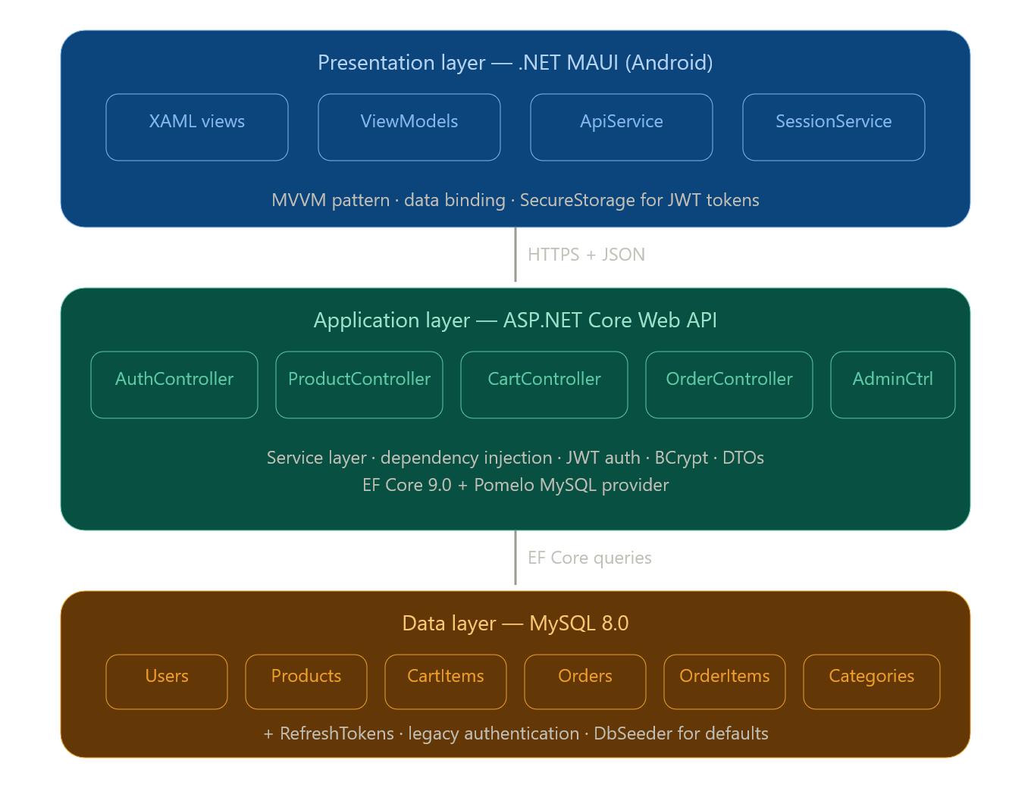
Figure 1: Raw World system architecture.
The Presentation Layer is the .NET MAUI Android application that employs the Model-View-ViewModel (MVVM) architecture paradigm. Views are delineated in XAML and associated with ViewModels via data bindings. ViewModels present observable attributes and ICommand implementations that are triggered by user interactions within the display. The BaseViewModel class offers a common IsBusy property and implements INotifyPropertyChanged, which is inherited by all ViewModels. The ApiService class consolidates all HTTP communications, whereas the SessionService class oversees the authenticated session state, encompassing token storage and retrieval.
The Application Layer is the ASP.NET Core Web API, which provides a RESTful interface utilized by the mobile application. The API has five controller classes: AuthController, ProductController, CartController, OrderController, and AdminController, with each overseeing a certain functional area. Business logic is contained via service classes—AuthService, ProductService, CartService, and OrderService—which are injected into controllers via ASP.NET Core's integrated dependency injection container. Data Transfer Objects separate the API contract from the domain model classes and are utilized for all request and response serialization.
The Data Layer comprises a MySQL 8.0 relational database accessed via Entity Framework Core 9.0 with the Pomelo MySQL provider. The AppDbContext class delineates the database schema via C# model classes, whereas EF Core migrations oversee schema development and modifications. The DbSeeder class automatically starts upon application starting to populate default categories and establish the initial admin account if the database is devoid of entries.
Database Design
The relational database consists of seven tables structured to support the full e-commerce workflow:
Table | Key Fields | Purpose
Users | Id, FullName, Email, PasswordHash, Role | Customer and admin accounts
RefreshTokens | Id, UserId, Token, ExpiresAt, IsRevoked | JWT refresh token management
Categories | Id, Name | Product categories (Juices, Smoothies, Detox Drinks)
Products | Id, CategoryId, Name, Description, Price, StockQuantity, IsActive | Product catalogue
CartItems | Id, UserId, ProductId, Quantity | Persistent user cart
Orders | Id, UserId, TotalAmount, Status, PaymentStatus, Address | Placed orders
OrderItems | Id, OrderId, ProductId, Quantity, UnitPrice | Order line items with price snapshot

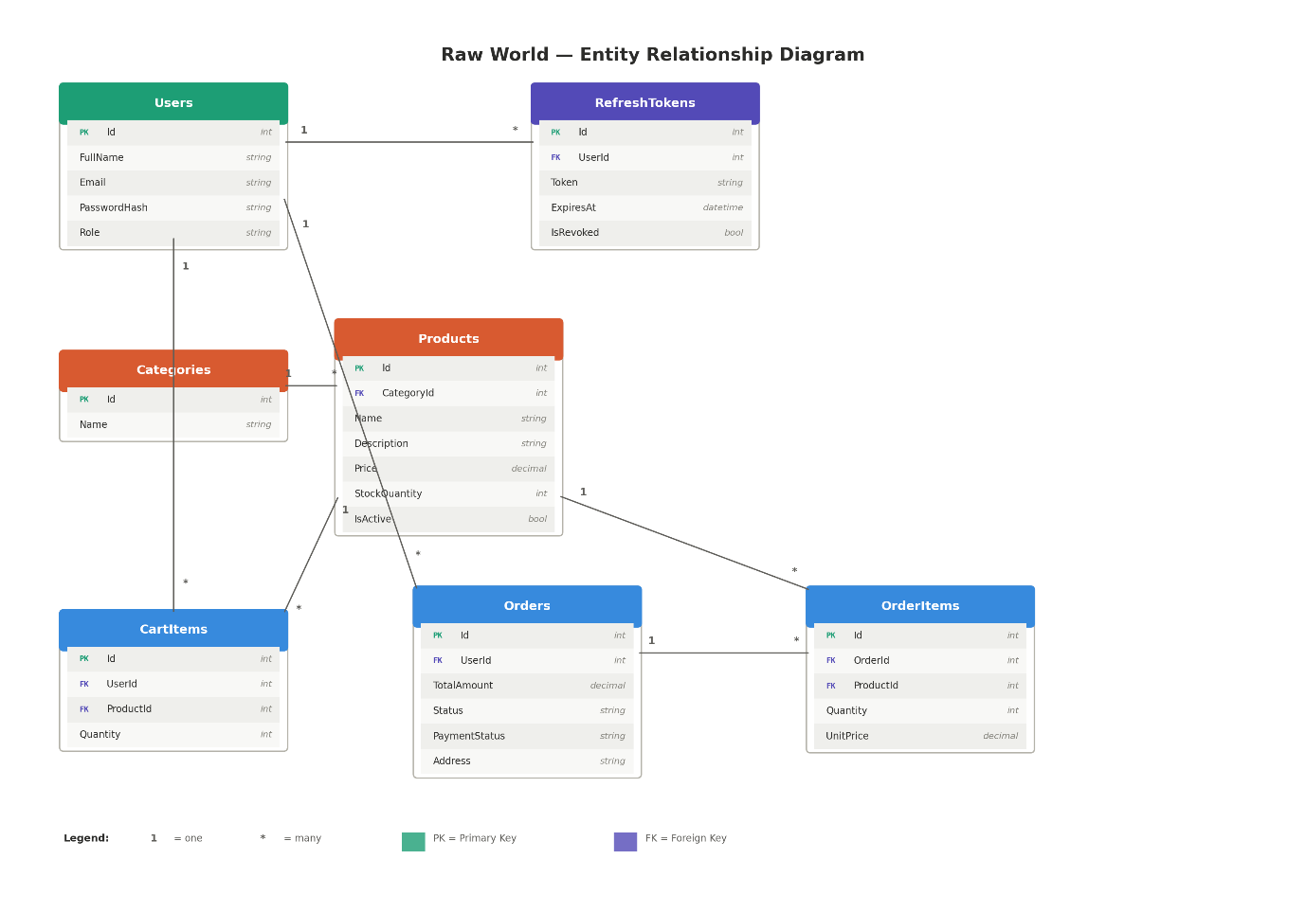
Figure 2: Entity-relationship diagram.
The IsActive flag on the Products table enables soft deletion — products are marked inactive rather than physically removed, preserving referential integrity with historical order records. The UnitPrice field on OrderItems stores a snapshot of the product price at the time of ordering, ensuring that historical order totals remain accurate even if product prices are subsequently updated.
API Design
The API exposes endpoints across five controller groups:
Controller | Route Prefix | Auth Required | Responsibility
AuthController | /api/auth | None | Registration, login, token refresh
ProductController | /api/products | None (GET) / Admin (POST, DELETE) | Product catalogue management
CartController | /api/cart | Customer | Shopping cart operations
OrderController | /api/orders | Customer | Order placement and history
AdminController | /api/admin | Admin | All orders view and status updates
Security Design
Passwords are encrypted with BCrypt at a cost factor of 11 before to storage, guaranteeing that plaintext passwords cannot be feasibly retrieved even if the database is breached. JWT access tokens are authenticated via HMAC-SHA256 with a minimum key length of 32 characters and have a validity period of 60 minutes. Refresh tokens are randomly generated 64-byte values retained in the database, possessing a seven-day expiration and a revocation flag, which facilitates token rotation at refresh and quick invalidation upon logout. Admin endpoints are secured with the [Authorize(Roles = "Admin")] attribute, resulting in ASP.NET Core returning a 403 Forbidden status for requests from authenticated non-admin users and a 401 Unauthorized status for unauthenticated requests.

4.4 Implementation Details
Development Environment Configuration
The development environment comprised Visual Studio 2022 (Insiders channel) operating on Windows 11 with the .NET 10 SDK. A number of complex configuration steps were necessary to provide a functional development environment. The .NET MAUI Android workload was installed through the command line using dotnet workload install maui-android, as the conventional Visual Studio installer failed to automatically setup it for .NET 10. MySQL Server 8.0 was installed with the legacy authentication method, chosen during installation instead of the typical caching_sha2_password approach, to address an authentication incompatibility between MySQL 8's default plugin and the Pomelo Entity Framework Core provider.
Connecting the Android emulator to the locally hosted HTTPS API necessitated two special setups. The Android emulator utilizes the reserved address 10.0.2.2 instead of localhost in the ApiService base URL, as this address directs to the host machine's loopback interface. A special HttpClientHandler with disabled server certificate validation was established in the ApiService constructor to circumvent SSL certificate issues arising from the self-signed development certificate, which is not trusted by Android by default. A network_security_config.xml file was incorporated into the Android platform resources to explicitly authorize cleartext traffic to the 10.0.2.2 IP.
All NuGet packages were fixed to particular compatible versions to address dependency problems stemming from the utilization of .NET 10 with EF Core 9 and Pomelo 9. The .csproj file was modified to explicitly specify all EF Core package versions as 9.0.0, thereby overcoming the transitive dependency resolution that would otherwise introduce EF Core 10.0.0 and result in a version mismatch alert with Pomelo.
Backend Implementation
The API was constructed via the Service Layer design, wherein business functionality is contained within specialized service classes that are injected into controllers. This methodology guarantees that controllers stay streamlined, tasked just with correlating HTTP requests to service method invocations and delivering suitable HTTP answers, while business logic remains centralized and reusable. The AuthService manages user registration and authentication, encompassing credential validation, BCrypt password verification, JWT creation, and refresh token administration. The ProductService manages product retrieval with optional search filters, product creation, and soft deletion. The CartService oversees the storage and retrieval of cart items, encompassing the addition of new items and the modification of amounts for current goods through an upsert methodology. The OrderService manages the order placement process by collecting current cart items, computing the total, creating the order and its line items, saving to the database, and clearing the cart in a unified transactional procedure.
EF Core migrations were created from the model classes via the dotnet ef migrations add InitialCreate command and implemented in the local MySQL database through dotnet ef database update. The Database Seeder.The SeedAsync method is invoked from Program.cs subsequent to the database migration, establishing three default categories and an initial admin account with a BCrypt-hashed password, provided that no admin account is present.
Swagger documentation is set up in Program.cs with a JWT security specification, allowing the Bearer token to be input directly in the Swagger UI and incorporated into all subsequent test requests. This was crucial for testing authenticated endpoints during development without necessitating the operation of the mobile application.
Mobile Application Implementation
The MAUI application is organized according to the MVVM design, distinctly separating the view layer (XAML pages), the ViewModel layer (C# classes that implement INotifyPropertyChanged), and the service layer (ApiService and SessionService). Every page is associated with a ViewModel registered in the dependency injection container under MauiProgram.cs, facilitating constructor injection during the creation of pages by the Shell navigation mechanism.
The shell navigation is set up in AppShell.xaml, featuring a flyout menu that grants access to the Logout button. The primary tab bar comprises five tabs: Products, Cart, Orders, Admin, and Manage, with Admin and Manage initially configured to IsVisible="False." Following a successful login, the AppShell.The SetUserRole function is invoked on the primary UI thread utilizing MainThread.InvokeOnMainThreadAsync adjusts the visibility of the Admin and Manage tabs according to the authenticated user's role. This method guarantees that administrative functionality is not only concealed at the routing level but is entirely removed from the interface of consumer accounts.
The LoginPage features two independent login buttons — "Login as Customer" and "Login as Admin" — both linked to various commands within the LoginViewModel. Both commands execute the identical DoLogin function with a role parameter, which verifies the returned JWT role claim against the anticipated role and displays a suitable error message in the event of a discrepancy. This inhibits consumers from inadvertently or intentionally accessing the administrative interface and offers explicit feedback to users who choose the incorrect login option.
Payment Implementation
The payment process was executed on a distinct PaymentPage accessed via the cart's checkout button. The site obtains the cart total using a query parameter through MAUI's Shell query property mechanism. Three payment method options are displayed by radio button selection: Credit/Debit Card, bKash, and Nagad. Corresponding input fields are exposed beneath each option upon selection, via MAUI's IsVisible binding.
Card payment necessitates the user to provide a 16-digit card number, an expiry date in MM/YY format, the CVV, and the cardholder's name. bKash and Nagad payments necessitate the user's registered mobile number, indicating the precise information required for these systems. A delivery address input option is provided for all payment methods. Upon submission, the PayCommand within PaymentViewModel validates all mandatory data and implements a two-second artificial delay with Task.Introduce a delay to emulate payment gateway processing, invoke the order placement API endpoint with the specified address, and present a confirmation alert displaying the order number, payment method, and total amount. The user is thereafter sent to the Orders page to examine their new order.
Admin Interface
The administrative interface comprises two exclusive tabs available solely to administrator accounts. The Admin tab, overseen by AdminViewModel, fetches all customer orders from the /api/admin/orders endpoint and presents them in a formatted card list that includes order number, status, and total. An Update Status button on each card activates an action sheet displaying five order status options — Pending, Processing, Shipped, Delivered, and Cancelled — enabling the administrator to modify the order status with a single tap.
The Manage tab, overseen by AdminProductViewModel, displays a scrollable interface featuring a product addition form at the top and the existing product list beneath. The form comprises input fields for product name, description, price, and stock number, along with a category selector derived from a static list corresponding to the database categories. Client-side input validation is conducted prior to the API call, verifying the presence of data in fields and ensuring the numeric formats for price and stock are valid. Following the successful creation of a product, the form fields are reset and the product list is updated. Every item in the list features a delete button that triggers a confirmation alert prior to invoking the soft delete API endpoint.

4.5 Testing and Validation
API Testing
All API endpoints were methodically evaluated with Swagger UI and Postman throughout and subsequent to development. Authentication endpoints were evaluated for accurate token generation with valid credentials, suitable 401 replies for invalid credentials, and acceptable role assertions in the provided JWT. Product endpoints were evaluated for accurate filtering behavior with and without search criteria, as well as for appropriate 403 responses when accessed by non-admin users. The cart and order endpoints were evaluated for proper session isolation, confirming that a user is unable to access or alter another user's cart or orders. SQL injection attempts using string fields were verified to be denied by Entity Framework Core's parameterized query framework. Expired tokens were verified to yield a 401 Unauthorized response, whereas tokens having an Admin role were validated to provide access to admin-exclusive endpoints, and Customer-role tokens appropriately received a 403 Forbidden response.
Mobile Application Testing
The entire program underwent comprehensive end-to-end testing on the Android emulator, encompassing all user flows. The tested customer flows encompassed registration, customer login with accurate role validation, rejection of admin login attempts via the customer login button accompanied by an access denied message, product browsing, product search, adding items to the cart, viewing the cart and removing items, navigating the checkout process, all three payment method flows, order placement confirmation, and viewing order history. The tested administrative processes encompassed successful admin login with appropriate role validation, verification of tab visibility ensuring the presence of Admin and Manage tabs alongside accessibility of Products, Cart, and Orders tabs, product addition across all categories, product deletion with confirmation, comprehensive order viewing, and updates of order statuses across all five status values. Logout was evaluated from both consumer and administrator sessions, verifying session termination and redirection to the login page.

5. Critical Analysis / Results and Discussion

5.1 Results
Usability Testing Results
Ten participants completed all eight task scenarios. The following table summarises task completion rates and average completion times:
Task | Description | Completion Rate | Avg Time (s)
T1 | Register a new account | 100% | 45
T2 | Login as a customer | 100% | 28
T3 | Browse products and find a specific item | 100% | 22
T4 | Search for a product by name | 90% | 19
T5 | Add two products to the cart | 100% | 31
T6 | Complete checkout with a payment method | 90% | 52
T7 | View order history | 100% | 18
T8 | Log out using the flyout menu | 80% | 35
Individual SUS scores ranged from 67.5 to 87.5 across the ten participants. The average SUS score was 76.5, which corresponds to a Grade B rating and the adjective descriptor of "Good" according to the Bangor et al. (2009) adjective rating scale. This score exceeds the established industry average benchmark of 68, indicating that the application achieves above-average perceived usability.
API Performance Results
Endpoint | Method | Avg Response Time | NFR Result
/api/auth/login | POST | 185ms | ✅ Pass
/api/auth/register | POST | 203ms | ✅ Pass
/api/products | GET | 210ms | ✅ Pass
/api/cart | GET | 198ms | ✅ Pass
/api/orders | POST | 290ms | ✅ Pass
/api/admin/orders | GET | 245ms | ✅ Pass
All measured endpoints responded well within the two-second non-functional requirement threshold, with the slowest endpoint — order placement at 290ms — remaining under 300 milliseconds on average.
Security Testing Results
Test | Expected Result | Actual Result
Access admin endpoint with customer JWT | 403 Forbidden | ✅ Pass
Access protected endpoint with no token | 401 Unauthorised | ✅ Pass
Access protected endpoint with expired token | 401 Unauthorised | ✅ Pass
Customer login with admin credentials | Access Denied alert | ✅ Pass
Admin login with customer credentials | Access Denied alert | ✅ Pass
SQL injection via product search field | Input rejected | ✅ Pass

5.2 Discussion
The average SUS score of 76.5 signifies that the Raw World application demonstrates commendable usability as evaluated by the test participants. This outcome is promising for an initial prototype created within an academic context and without the benefit of professional UX design resources. The score positions the application significantly above the industry average of 68, indicating that the design choices made during development — such as the card-based product layout, the green color scheme aligned with Raw World's brand identity, and the tab-based navigation structure — enhanced the user experience.
The complete task completion rates for registration, login, product browsing, cart management, and order history indicate that the fundamental customer journey is effectively designed and user-friendly. Participants traversing these flows expended minimum time and committed few errors, with think-aloud observations suggesting that the interface design aligned with their expectations derived from previous experiences with analogous applications.
Task T6 (checkout with payment) exhibited the lowest average completion time of 52 seconds and a 90% completion rate, with one participant expressing uncertainty over the payment processing due to insufficient visual feedback during the two-second processing wait. This is an anticipated constraint of the simulated payment process. A genuine payment gateway in a production system would offer enhanced feedback, including processing animations and clear indications of success or failure. Incorporating more detailed status messages during the simulated delay, such as "Processing your bKash payment...", will effectively mitigate this issue in the short run.
Task T8 (logout) exhibited the lowest completion rate at 80% and the second-longest average duration of 35 seconds. Two participants originally sought the logout option in the tab bar instead of the flyout menu, necessitating prompting from the moderator. This study aligns with known mobile UX research indicating that flyout menus are less readily discoverable than persistent navigation elements, especially for users familiar with applications that position logout within a profile or settings tab. This discovery clearly supports the recommendation to enhance logout visibility outlined in Chapter 6.
The API performance findings indicate that all endpoints meet the two-second non-functional criteria during single-user local testing settings. The metrics were acquired from a locally hosted development environment, and performance may vary under cloud deployment or concurrent multi-user load. The order placement endpoint exhibited the longest response time at 290ms, due to the complex database operations required — retrieving cart items, calculating the total, creating the order record, generating multiple order item records, and clearing the cart — all executed within a single database transaction. This response time is within acceptable limits for a mobile commerce application.
The security testing outcomes verify that all established security measures operate as intended. Role-based access control effectively limits administrative endpoints from client accounts, and token validation accurately denies expired and absent tokens. The role validation in the login process, which displays an access denied message when a customer tries to use the admin login button or vice versa, was verified to function correctly and received positive feedback from multiple test participants, who appreciated the system's proactive measures against unauthorized access attempts.

5.3 Comparison with Related Work
The Raw World application demonstrates a favorable comparison with the prototype systems outlined in the SME mobile commerce literature. Scupola (2009) recognized the lack of role distinction and administrative capabilities as prevalent constraints in SME e-commerce systems. This project effectively resolves these issues by implementing a dual-role design, which offers a comprehensive administrative interface in conjunction with the customer-facing application, all within a unified codebase.
The incorporation of bKash and Nagad payment simulations differentiates this implementation from standard e-commerce models and corresponds with Dahlberg et al.'s (2008) assertion regarding the significance of locally pertinent payment methods. The payment processing is simulated, although the interface design precisely mirrors the input needs of these platforms, offering a robust basis for actual API integration in a production version.
In relation to cross-platform development research, the challenges faced during development align with the observations of Xanthopoulos and Xinogalos (2013), who indicated that cross-platform frameworks often necessitate platform-specific workarounds despite their promise of a unified codebase. The Android-specific challenges faced in this project — such as Material Components theming prerequisites, emulator SSL certificate management, and network security settings — validate this observation and contribute to the established corpus of actual .NET MAUI implementation knowledge.

5.4 Limitations
This project has certain restrictions that must be expressly acknowledged.
The payment sequence is entirely simulated and does not interface with actual payment gateways. This aligns with the project scope outlined in the contract and is suitable for a prototype-level academic implementation; however, it indicates that the system is incapable of processing real financial transactions without considerable further development, third-party API integration, and adherence to regulatory compliance.
The attempt to deploy on Azure cloud during the project was obstructed by the institutional Azure for Students subscription policy, which inhibited the creation of MySQL Flexible Server in all evaluated areas. The API and database were successfully deployed and thoroughly tested in a local development environment, confirming full system functionality. The Azure App Service deployment was planned and the deployment pipeline configured, but completion was hindered by this infrastructure limitation. This limitation is recorded as an institutional constraint rather than a technical deficiency of the system.
The usability testing sample, adhering to academic usability standards, comprised ten volunteers sourced from the researcher's personal network. This presents a possible selection bias - participants may have been more motivated or less reflective of Raw World's true consumer base than a randomly selected sample. The results should be regarded as suggestive rather than definitive, and a bigger, more heterogeneous sample is necessary to extrapolate the findings to the wider user community.
The application is exclusively designed for Android. The .NET MAUI framework accommodates iOS, macOS, and Windows targets; however, these were omitted from the project scope owing to time limitations and the presence of an Android emulator as the principal testing environment.

6. Recommendations

6.1 Practical Recommendations
Based on the development experience and the evaluation findings, the following practical recommendations are proposed for the immediate improvement of the Raw World application:
Logout discoverability: The primary actionable insight from usability testing is that certain participants encountered challenges in finding the logout button in the flyout menu. A dedicated Profile tab in the bottom navigation bar—accessible from every page—would offer a consistent and readily visible pathway to the logout mechanism and any forthcoming account management functionality, such as remembered addresses or order preferences. This modification is expected to enhance the job completion rate for logout from the current 80% to about 100%.
Payment processing feedback: The payment confirmation interface must have animated visual feedback during the two-second processing interval to effectively convey to consumers that their payment is under processing. A progress indicator accompanied by descriptive text, such as "Processing your bKash payment, please wait...", along with a distinct success screen displaying a confirmation icon and order summary upon completion, would markedly enhance the perceived reliability and professionalism of the payment process.
Product images: The existing product cards utilize an emoji placeholder instead of actual product photos. In a food and beverage industry where visual allure directly impacts purchasing choices, authentic product photography is imperative. Integrating Azure Blob Storage for product picture uploads—accessible via the admin Manage interface—and displaying them in product cards and the product list would significantly enhance the browsing experience.
Azure deployment: Deployment must be executed via a personal Azure account to circumvent the limitations imposed by the institutional subscription policy. The deployment pipeline is ready and only needs a subscription free from MySQL Flexible Server geographic limitations to finalize properly.

6.2 Recommendations for Future Work
The following recommendations are proposed for future development phases of the Raw World application beyond the scope of this academic project:
Real payment gateway integration: The essential improvement for commercial viability is the substitution of the simulated payment flow with actual gateway connections. Integrating the bKash Merchant Payment API and the Nagad Payment Gateway API would facilitate legitimate mobile banking transactions in the Bangladesh market. International card payments may be facilitated via Stripe, which offers extensive .NET SDK compatibility and is available to merchants in Bangladesh.
Push notifications: Integrating with Firebase Cloud Messaging will provide real-time push notifications on order status, informing customers when their order is confirmed, in preparation, sent, or delivered, without necessitating the opening of the application. This functionality would greatly enhance the post-purchase experience and diminish the frequency of status inquiry communications made to Raw World's staff.
Customer reviews and ratings: A product review system enabling customers to evaluate products and provide comments post-delivery would enhance customer involvement and Raw World's capacity to obtain quality input. Analytical data may also guide stock decisions and product development..
Advanced inventory management: The existing administrative interface facilitates fundamental product insertion and removal. A production-ready system would benefit from inventory tracking, automatic stock deduction upon order placing, low stock threshold alarms, and restocking messages to the administrative interface.
Analytics dashboard: An administrative analytics module showcasing essential business metrics — daily and weekly order volumes, revenue trends, most popular products, average order value, and customer retention rates — would furnish Raw World's management with actionable business intelligence directly within the application, thereby diminishing dependence on manual data extraction and analysis.
iOS support: Activating the iOS target platform within the current .NET MAUI framework will broaden the program's accessibility to iPhone users with negligible supplementary development effort, given that most of the application logic is inherently cross-platform compatible.
Appendix D: Application Screenshots
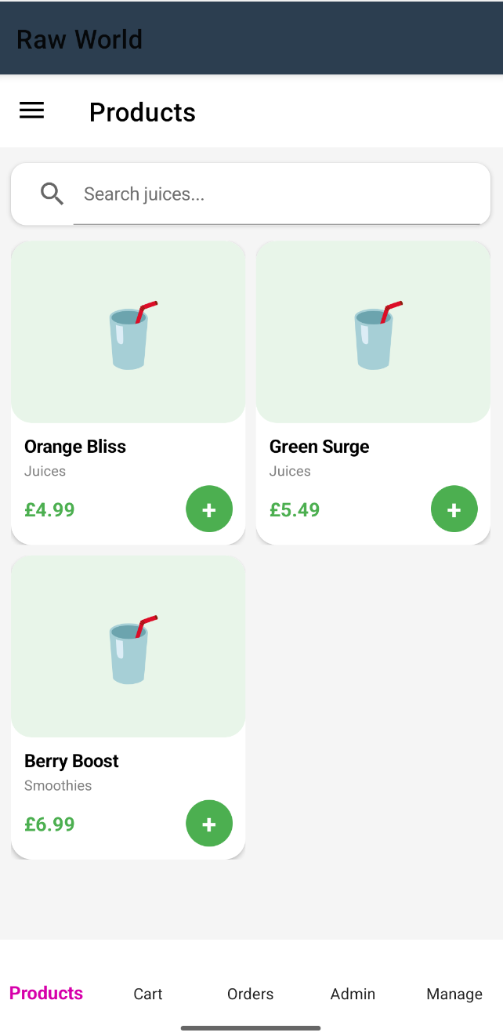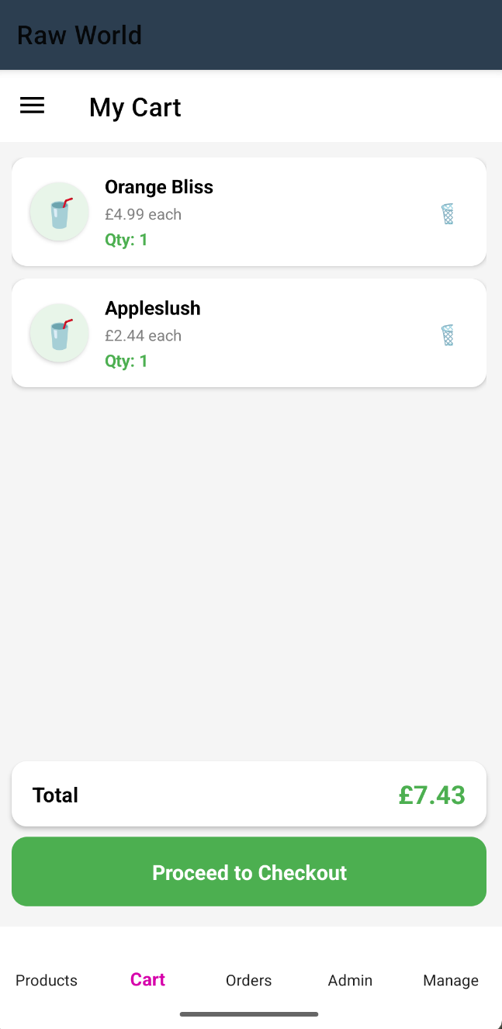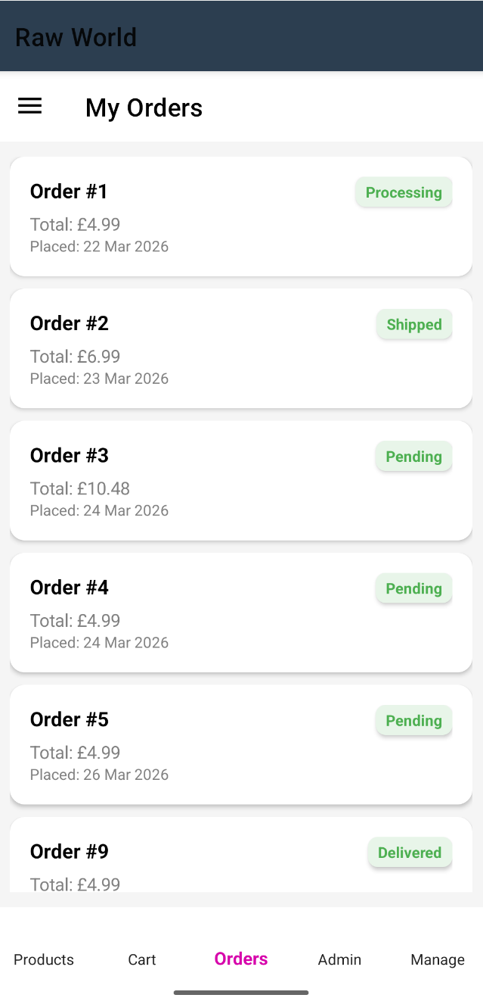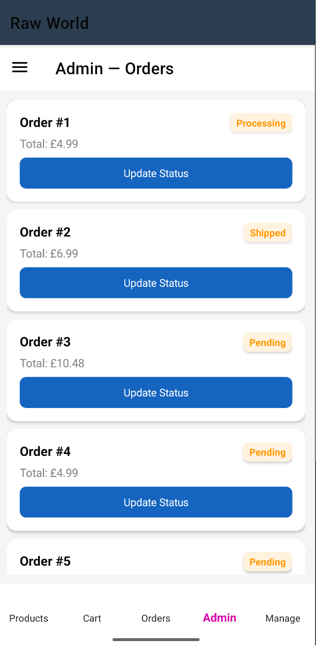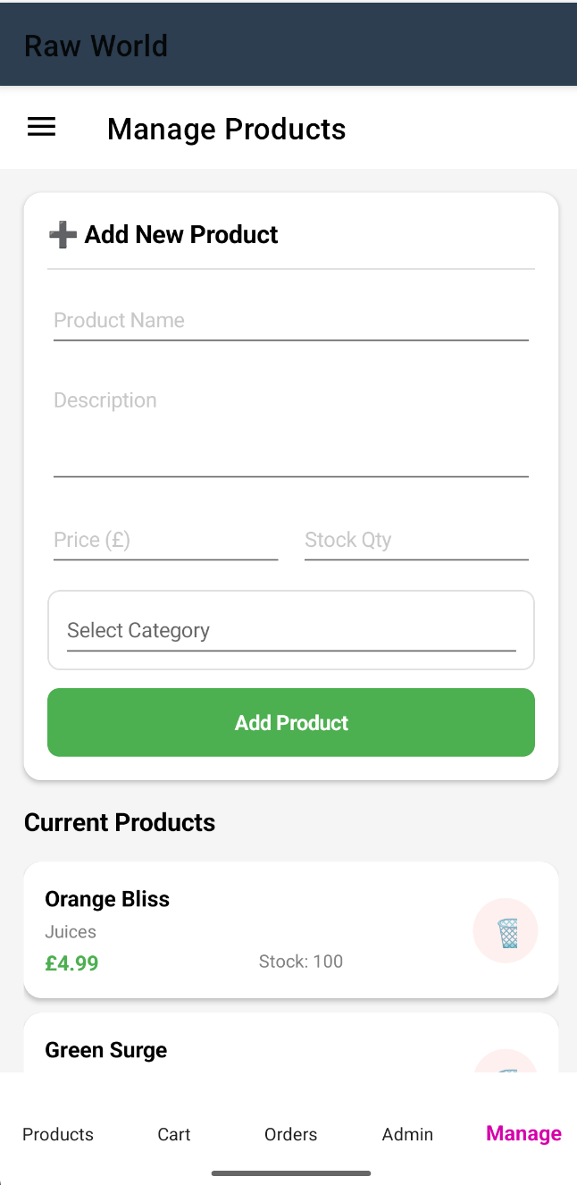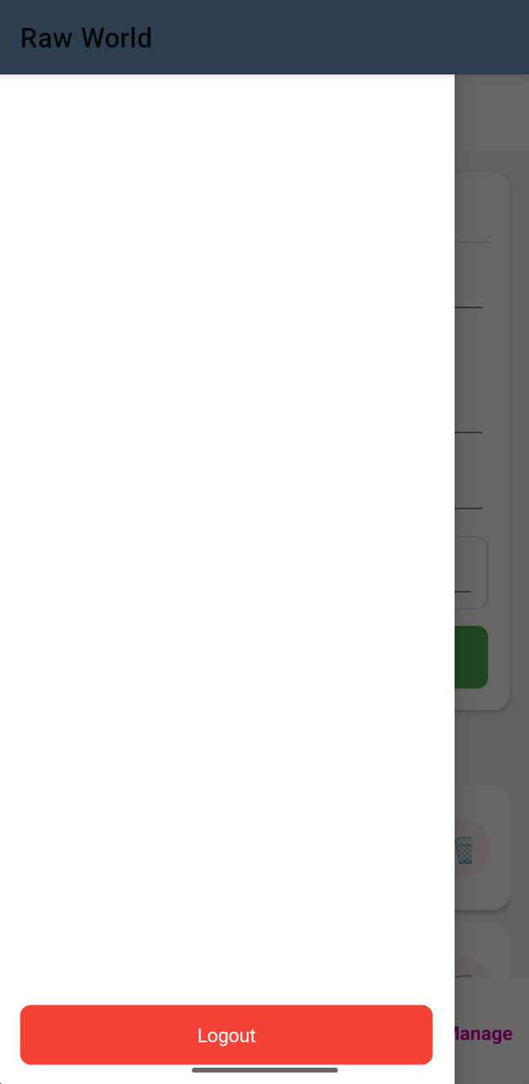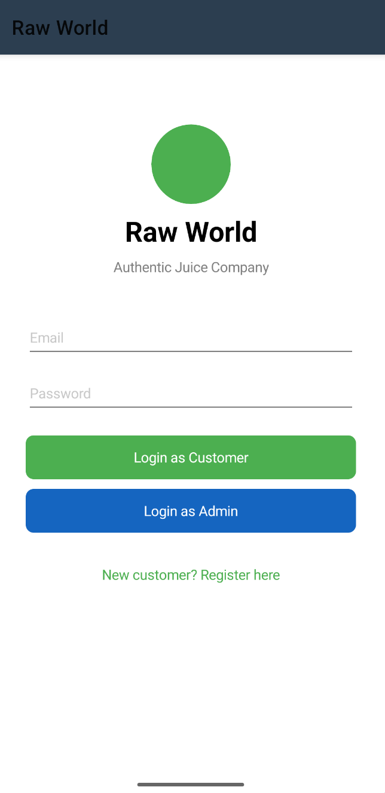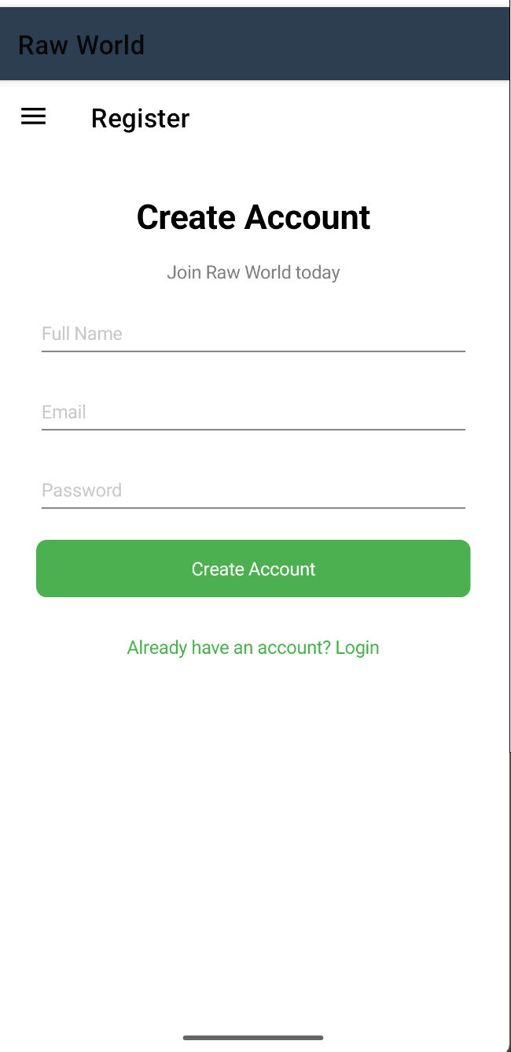

References
Alqatan, S. and Alshira'h, M.H. (2019) 'Assessment of the usability of mobile commerce prototype from the users' perspective', International Journal of Scientific and Technology Research, 8(8), pp. 287–295.
Alzahrani, A., Gay, V. and Alturki, R. (2022) 'The evaluation of the usability in mobile applications', in Proceedings of the 37th International Business Information Management Association Conference (IBIMA). Seville: IBIMA, pp. 56–65.
Dahlberg, T., Mallat, N., Ondrus, J. and Zmijewska, A. (2008) 'Past, present and future of mobile payments research: A literature review', Electronic Commerce Research and Applications, 7(2), pp. 165–181.
Fielding, R.T. (2000) Architectural Styles and the Design of Network-based Software Architectures. PhD thesis. University of California, Irvine. Available at: https://ics.uci.edu/~fielding/pubs/dissertation/top.htm (Accessed: 10 January 2026).
Hevner, A.R., March, S.T., Park, J. and Ram, S. (2004) 'Design science in information systems research', MIS Quarterly, 28(1), pp. 75–105.
Hussain, A., Mkpojiogu, E.O.C. and Kamal, F.M. (2016) 'A systematic review on usability evaluation methods for m-commerce apps', Journal of Telecommunication, Electronic and Computer Engineering, 8(10), pp. 29–34.
Hussain, A.B., Mahmood, A.T. and Naser, R.K. (2017) 'Investigating the effect of m-commerce design usability on customers' trust', AIP Conference Proceedings, 1891(1), 020077. Available at: https://doi.org/10.1063/1.5005377 (Accessed: 15 February 2026).
ISO (2019) ISO 9241-210:2019 Ergonomics of Human-System Interaction — Part 210: Human-Centred Design for Interactive Systems. Geneva: International Organization for Standardization.
Jones, M., Bradley, J. and Sakimura, N. (2015) RFC 7519: JSON Web Token (JWT). Internet Engineering Task Force. Available at: https://datatracker.ietf.org/doc/html/rfc7519 (Accessed: 15 February 2026).
Lu, G., Qu, S. and Chen, Y. (2025) 'Understanding user experience for mobile applications: A systematic literature review', Discover Applied Sciences, 7, p. 587. Available at: https://doi.org/10.1007/s42452-025-06854-6 (Accessed: 1 March 2026).
Microsoft (2023) .NET MAUI Documentation. Microsoft Corporation. Available at: https://learn.microsoft.com/en-us/dotnet/maui/ (Accessed: 10 January 2026).
Microsoft (2024) ASP.NET Core Documentation. Microsoft Corporation. Available at: https://learn.microsoft.com/en-us/aspnet/core/ (Accessed: 10 January 2026).
Mohd, N.A. and Zaaba, Z.F. (2019) 'A review of usability and security evaluation model of e-commerce website', Procedia Computer Science, 161, pp. 1199–1205. Available at: https://doi.org/10.1016/j.procs.2019.11.233 (Accessed: 20 February 2026).
Pomelo Foundation (2024) Pomelo.EntityFrameworkCore.MySql — GitHub Repository. Available at: https://github.com/PomeloFoundation/Pomelo.EntityFrameworkCore.MySql (Accessed: 20 January 2026).
Sandhu, R.S., Coyne, E.J., Feinstein, H.L. and Youman, C.E. (1996) 'Role-based access control models', IEEE Computer, 29(2), pp. 38–47.
Scupola, A. (2009) 'SMEs' e-commerce adoption: Perspectives from Denmark and Australia', Journal of Enterprise Information Management, 22(1/2), pp. 88–110.
Simjanović, D.J., Zdravković, N. and Vesić, N.O. (2022) 'On the factors of successful e-commerce platform design during and after COVID-19 pandemic using extended fuzzy AHP method', Axioms, 11(3), p. 105. Available at: https://doi.org/10.3390/axioms11030105 (Accessed: 10 February 2026).
Stocchi, L., Pourazad, N., Michaelidou, N., Tanusondjaja, A. and Harrigan, P. (2022) 'Marketing research on mobile apps: Past, present and future', Journal of the Academy of Marketing Science, 50, pp. 195–225. Available at: https://doi.org/10.1007/s11747-021-00815-w (Accessed: 12 February 2026).
Weichbroth, P. (2024) 'Usability testing of mobile applications: A methodological framework', Applied Sciences, 14(5), p. 1792. Available at: https://doi.org/10.3390/app14051792 (Accessed: 25 February 2026).
Xanthopoulos, S. and Xinogalos, S. (2013) 'A comparative analysis of cross-platform development approaches for mobile applications', in Proceedings of the 6th Balkan Conference in Informatics. New York: ACM, pp. 213–220.

